## horizontal line

Choose Your Path

(Started: Oct. 25, 2016) (Ended: TBA)



Team: The Lovelaces

Members:

Teresita C. G. Nader (ONID ID: Guzmannt)

Christa Wright (ONID ID: wrighch3)

Savannah Loberger (ONID ID: loberges)

# Overview

The game we will be developing is called “Choose Your Path”. There will be three different pages for the project. The game will be set up in a choose-your-own adventure style, where the user will create their character, which will be implemented into the game. When the user first creates their character, the user becomes the character that is in the story. Depending on the choices the user makes it will affect the rest of the adventure and eventually the end. After finishing the story the user will have an option to move through the story again. They can always restart the game and create a new character to move through a new story of their choosing.

# Goals

1. Create a dynamically interesting and unique experience for the user to play.
2. Allow the user to feel integrated into the story based off their user name and other information provided at the beginning of the game.

# Specifications

At the end of a Choose Your Path game, there will be charts to display the percentage of other times this ending, and other endings of the game were reached. So the user will be able to compare their ending to others, by being able to tell if they are part of a majority, or minority.

For the time being we are only going to assume one user. We will store data about the player’s character through the story including various features such as the endings other users have gotten, along with giving the option for the user to make games of their own. These games will be saved on the site and made public for others to play through as well.

Starting off, there will be three games for the users to choose from. The user will be able to restart the game anytime they want, or continue playing the game until the end. The game will not save the user’s place in the game. The website will also allow users to make their own games, with unique endings. The games will be stored in the database of Choose Your path. These games will be featured on the website, allowing users to host their own games on the page. When the user decides to make their own game, they will be provided with a HTML template, with the format provided. It will notify the user if they have an empty text box, and will insist that the user completes the form to progress making their game.

# Milestones

## Week 1

Have the main frame of the site built, have a plan for CSS for all the pages.

## Week 2

Have the About page finished, with CSS implemented into it. Begin writing the game.

## Week 3

Develop how functionality of the site, and the game. Ideally, have the storylines mostly written out, while implementing functionality to it.

## Week 4

User testing, look for bugs in the code.

## Week 5

Polish this beautiful website we will be spending so much time making.

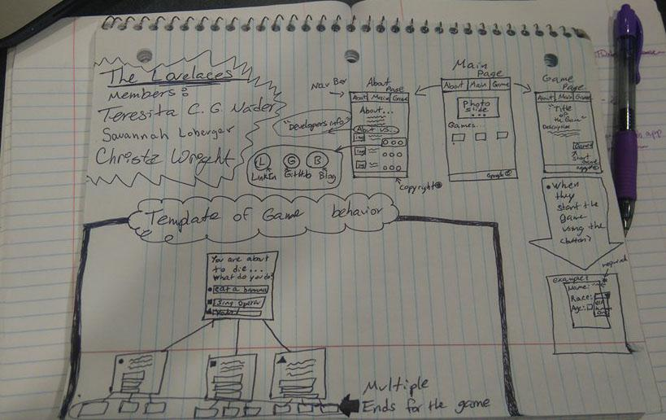

|  |  |  |
| --- | --- | --- |
| **Member** | **Task** | **Notes** |
| Teresita | Home.html and Games.html |  |
| Christa | Games.html and CSS for about page |  |
| Savannah | Description of About and Games.html |  |

Note: Here we will add the task that each of us is in charge of.